**Install and Configure ProFTPD Server**

**FTP servers are the piece of software that allows you to create a FTP connection between your local computer and a web server. ProFTPD is a FTP server for Unix/Linux servers, very configurable and very effective, it is free & open-sourced, released under the GPL license.**

sudo apt-get update

apt-get install proftpd

**###########Configure ProFTPD Server##############**

vi /etc/proftpd/proftpd.conf

1. **ServerName**: Make it your default server name.
2. **UseIPV6:** You may switch it to “Off“, if you don’t use it.
3. **DefaultRoot** : Uncomment this line to restrict users with their home folders.
4. **RequireValidShell**: Uncomment this line and make it “On” to enable logging in for users, even for those who doesn’t have a valid shell in /etc/shells to log in.
5. **AuthOrder**: Uncomment the line to enable the using of local passwords.
6. **Port**: This line defines the default port for the FTP server, it is 21 by default. If you want, you can define any custom port here.

systemctl restart proftpd

**#########Create a FTP users##############**

useradd -m kittu (m=create home directory)

passwd kittu

**If you want to give limited access then you have to uncomment defualtRoot in /etc/proftpd/proftpd.conf .**

DefaultRoot ~

touch /home/kittu/max

**then you have to mention this user in /etc/proftpd/proftpd.conf**

user kittu

systemctl restart proftpd

**You can now go to following addresses on the browser, , it will ask you about the user name and the password.**

ftp://192.168.72.77

OR

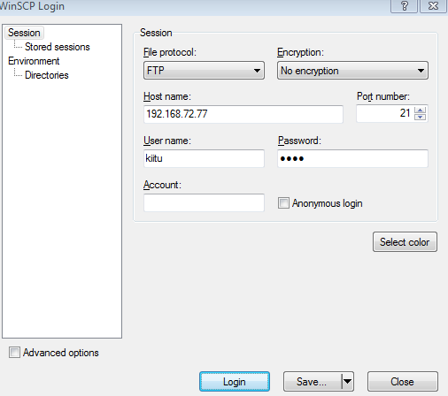

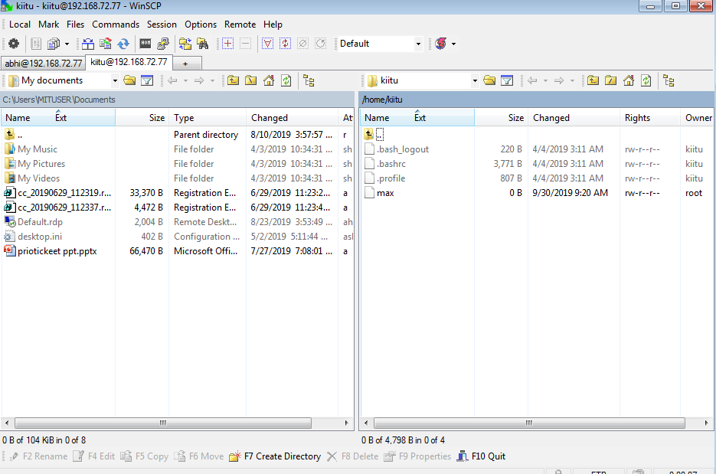

**If you want to add multiple user then you have create group and put users in this group.**

groupadd admin

useradd -m kit mit dit

**assign passwords for above users.**

usermod -G admin kit mit dit

**you can change home directory,**

**for example**

mkdir /opt/public

usermod -d /opt/public kit

**then you have to mention this group in /etc/proftpd/proftpd.conf**

**group admin**

systemctl restart proftpd